Noah McCarthy
Assignment 11.2
Coding Standards
In this paper, I plan to discuss coding standards expected in the professional field of software engineering. I will discuss what coding standards are, the types of coding standards, their advantages and disadvantages, and their importance.
To start off, let’s discuss what coding standards are. They are basically the rules and guidelines for how developers should implement their code and how to go about coding. According to Lucas Wyland, Founder and CTO of Steambase, “Coding standards should be outcome-driven. Many organizations have process-driven rules like ‘all functions must follow a strict verb_noun() format.’ Hard pass on these! Instead, set outcome-driven rules—like ‘function names should clearly explain intention.’” (Wyland, as cited in Codacy, n.d.) What I take from this is that coding standards should have a thorough and logical reason as to why they should exist. For example, it would be weird to mandate that all the variable names start with pineapple.
As for the types of coding standards, there are two. They are known as Open and Closed coding standards. An open coding standard is a form of guidelines that are more so open to the public or community. They are basically the basic rules and guidelines that the public software development and security communities agree upon that should be basic standard practice. Then there is closed coding, you might see where this is going. Close coding is more about dealing with companies and their own personal coding standards, and they don’t want those coding standards to be known externally.
However, we need to know what the advantages and disadvantages of open and closed coding standards are. First, lets talk about how each approach tackles maintainability and consistency. With open coding standards, the approach is more dynamic, as if you rely too much on the open coding standards, it frequently changes, making it harder to stay up to date with the public’s latest rules and guidelines for coding. Then there is the closed coding where you’re in a company and that company's standards aren’t going to be as dynamic as people constantly discussing and bringing new ideas to the standard on the public side of coding standards. Plus, the company will probably only admit changes to the coding standards if they align with the company's goals and if its technology is capable. Then there is the talks of collaboration. This is where the advantages of open coding practices come in to play. With open coding practices, anyone new to the team will be able to more easily get acquainted with the organization's projects, as they don’t have to learn a whole new lingo or guidelines for the projects they are about to work on. However, this is where the disadvantage of close coding comes in, where more time will be needed to get new hires familiar with the coding practices of the company. Then there is the idea of security. Open coding standards will be weaker in this regard, as your coding practices and guidelines are public and more easily predictable for a threat actor to take advantage of. Then there are the closed practices where the coding standards are within the company, which means a bit more in the unpredictability section, as a threat actor won’t be able to easily take advantage of your coding practices, as they would probably be a bit different than public ones. Overall, they both have their advantages and disadvantages. I think open coding standards make more sense when you’re doing a solo thing or a public project, while companies should use their own closed coding standards.
Now, let's discuss the key importance of coding standards. Ultimately, higher-quality code tends to mean more secure and safe code. With coding standards, making higher-quality code is a lot easier, and it basically gives you a track to get there, as the coding standards are guidelines to get you where you need to be. The coding standards force you to uphold standards that keep the code clean and organized. This then allows for easier debugging of the code. The standards also help you to ensure you are meeting compliance regulations like HIPAA. You don’t want to be the one responsible for breaking a government regulation, so the coding standards help with that. Lastly, the coding standards allow you to keep our code secure through diligent practice and allow you to practice an important part of DevOps, making frequent code commits, allowing quicker updates for users.
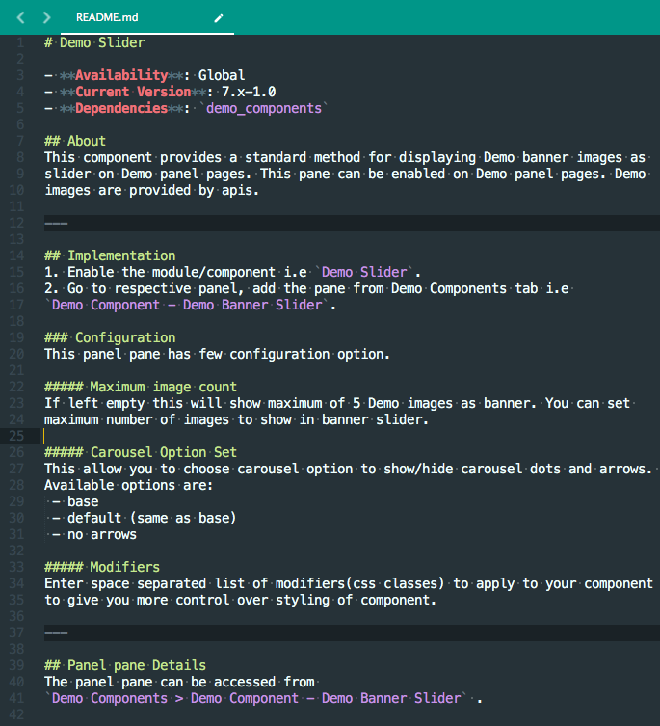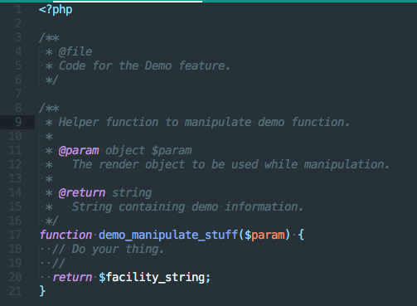
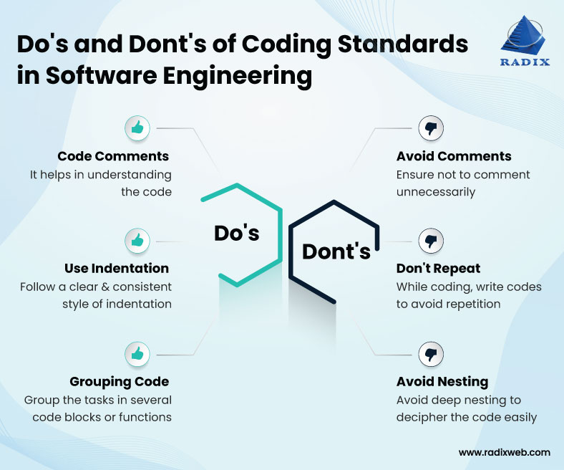

References
Codacy. (2026, March 4). Coding standards: What are they and why are they important? https://blog.codacy.com/coding-standards

